Unit 6: Transformations
Lesson 1: Shifts
Objectives:
- I can identify parent functions
- I can identify different types of transformations (shifts) from parent functions
- I can sketch functions and their transformation (shifts)
Agenda:
- Use your skills
- Use all your skills
- Challenge your skills
Vocabulary:
- Function, parent function, transformed function, vertical shift, horizontal shift.
Focus Questions:
- How do we describe the difference between the graphs of any function and its parent function?

Online support:
https://www.youtube.com/watch?v=nzwdRWmPH9o
https://www.youtube.com/watch?v=IFT2uznB7fM
https://www.youtube.com/watch?v=7S5HF38DnUY

Online Practice:
https://www.purplemath.com/modules/fcntranq.htm
https://www.ixl.com/math/algebra-2/function-transformation-rules

Homework:
Finish the portfolio for Unit 5. Unit test is on Wednesday/Thursday (1- 8 and 1- 9-20)

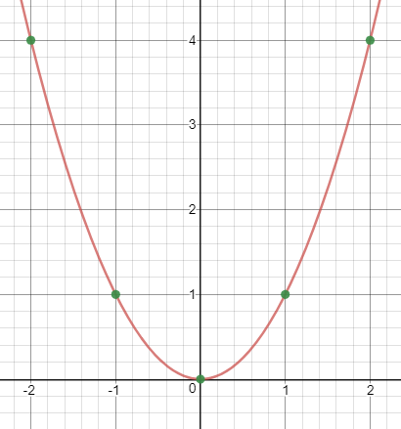
A
Parent Function $f\left(x\right)=x^{2}$

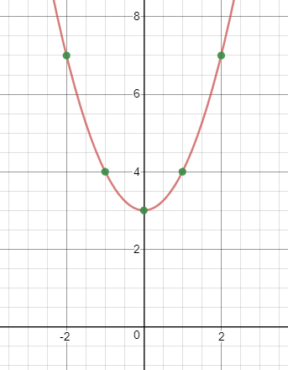
$$t\left(x\right)=x^{2}+3$$
B
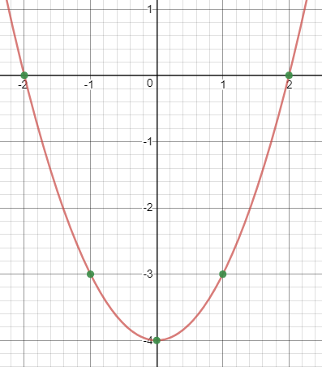
C
$$w\left(x\right)=x^{2}-4$$

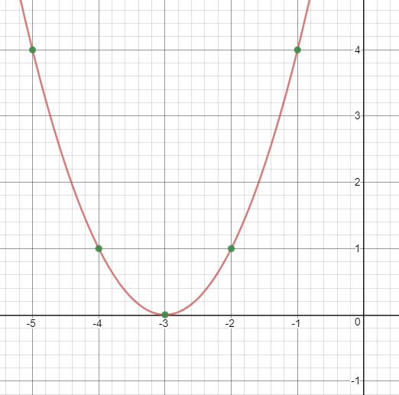
D
$$z\left(x\right)={(x+3)}^{2}$$

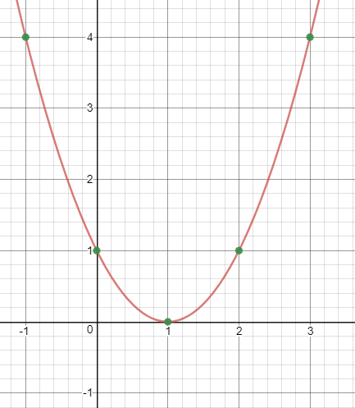
E
$$h\left(x\right)={(x-1)}^{2}$$

Match the correct graph with the correct function

Do Now: one graphing question from the portfolio.

Lesson 6-1: Class Notes:
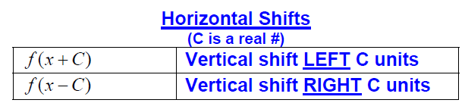
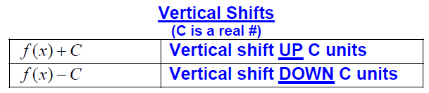
Horizontal
Horizontal

- Name the parent function first then explain how each graph has changed from its parent function. You might sketch if you choose.

- $f\left(x\right)=\left|x\right|-3$ ___________________________________________________________

- $f\left(x\right)=x^{2}+5$ ___________________________________________________________

- $f\left(x\right)=\sqrt{x-6}$ ___________________________________________________________

- $f\left(x\right)=\sqrt[3]{x+2}$ ___________________________________________________________

- $f\left(x\right)={(x-1)}^{3}+4$ ___________________________________________________________

2)Give the name of the parent function, describe the transformation represented, and state the domain and range.

- $g\left(x\right)=x^{2}-1$ Name: ______________________________________

Sketch here: Transformation: ________________________________________________________

Domain: ________________________ Range: _____________________________

- $f\left(x\right)=\left|x-1\right|-6$ Name: ______________________________________

Transformation: ________________________________________________________

Domain: ________________________ Range : _________________

- $f\left(x\right)=\sqrt{x-4}$ Name: _____________________________________________________________

Transformation: ________________________________________________________

Domain: ________________________ Range : _____________________________

Practice:
Sketch the following transformations. $f\left(x\right)=x^{2}$
Use the Function Transformation word bank above to describe the transformation that changed the parent function f(x) to the transformed functions

$$g\left(x\right)=f\left(x\right)+5$$  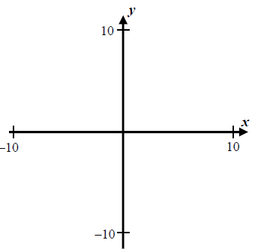  Transformation: | $$g\left(x\right)=f\left(x\right)-1$$  Transformation: | $$g\left(x\right)=f\left(x-2\right)$$  Transformation:
$$g\left(x\right)=f\left(x+6\right)$$  Transformation: | $$g\left(x\right)=f\left(x+3\right)-2$$  Transformation: | $$g\left(x\right)=f\left(x-4\right)+1$$  Transformation:
Name: _____________ Date: _______________
Homework 6-1: Due after the Unit test.
Sketch the following transformations from f(x) without a calculator. Use the Function Transformation word bank above to describe the transformation that changed the parent function f(x) to the transformed functions
Parent Function $f\left(x\right)=\left|x\right|$ | $$t\left(x\right)=\left|x\right|+2$$  Transformation: | $$w\left(x\right)=\left|x\right|-4$$  Transformation:
$$z\left(x\right)=\left|x-3\right|$$  Transformation: | $$h\left(x\right)=\left|x+5\right|$$  Transformation: | $$h\left(x\right)=\left|x+3\right|-4$$  Transformation:

Sketch the following transformations from f(x) without a calculator. Use the Function Transformation word bank above to describe the transformation that changed the parent function f(x) to the transformed functions
Parent Function $f\left(x\right)=\sqrt{x}$ | $$t\left(x\right)=\sqrt{x}+3$$  Transformation: | $$w\left(x\right)=\sqrt{x-5}$$  Transformation:

